DATA STRUCRURES & ALGORITHMS

GAJULA CHANDANASREE

M220350EC

M.TECH - EDT

**SET 1 – Q1.**

#include<iostream>

#include<iomanip>

using namespace std;

struct items{

float quantity;

float price;

};

int main(){

struct items item1,item2,item3,item4,item5;

item1.price=15,item2.price=20,item3.price=10,item4.price=6,item5.price=12;

cout<<"Enter the quantity of item1"<<endl;

cin>>item1.quantity;

cout<<"Enter the quantity of item2"<<endl;

cin>>item2.quantity;

cout<<"Enter the quantity of item3"<<endl;

cin>>item3.quantity;

cout<<"Enter the quantity of item4"<<endl;

cin>>item4.quantity;

cout<<"Enter the quantity of item5"<<endl;

cin>>item5.quantity;

cout<<"*******Receipt*******"<<endl;

cout<<"_______________"<<endl;

cout<<"Total price for item1 is"<<setw(15)<<setprecision(5)<<(item1.price)*(item1.quantity)<<endl;

cout<<"Total price for item2 is"<<setw(15)<<setprecision(5)<<(item2.price)*(item2.quantity)<<endl;

cout<<"Total price for item3 is"<<setw(15)<<setprecision(5)<<(item3.price)*(item3.quantity)<<endl;

cout<<"Total price for item4 is"<<setw(15)<<setprecision(5)<<(item4.price)*(item4.quantity)<<endl;

cout<<"Total price for item5 is"<<setw(15)<<setprecision(5)<<(item5.price)*(item5.quantity)<<endl;

cout<<"\n";

cout<<"---------------------------------------------"<<endl;

cout<<"Total price:"<<setw(27)<<(item1.price)*(item1.quantity)+(item2.price)*(item2.quantity)+

(item3.price)*(item3.quantity)+(item4.price)*(item4.quantity)+(item5.price)*(item5.quantity)<<endl;

cout<<"---------------------------------------------"<<endl;

return(0);

}

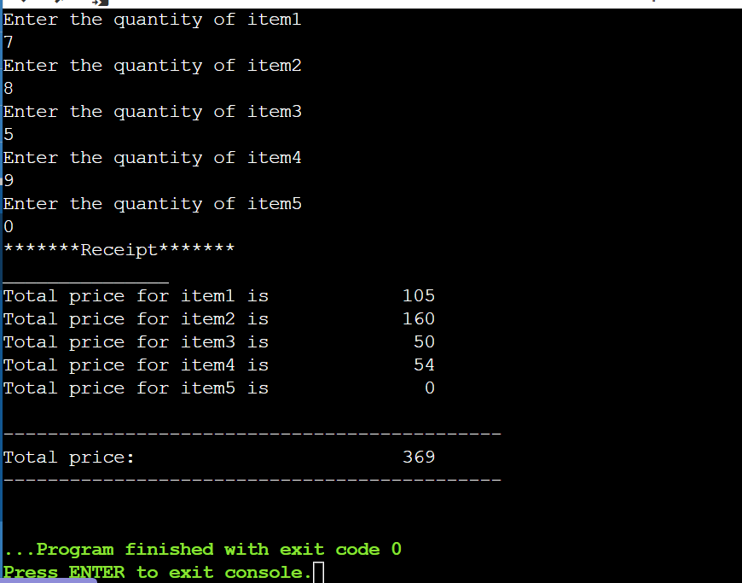

**SET 1 - Q2.**

#include <iostream>

using namespace std;

int main() {

int marks;

cout << "Enter marks (out of 100):";

cin >> marks;

switch(marks/10)

{

case 9: cout << "Your grade is S"; break;

case 8: cout << "Your grade is A"; break;

case 7: cout << "Your grade is B"; break;

case 6: cout << "Your grade is C"; break;

case 5: cout << "Your grade is D"; break;

case 4: cout << "Your grade is E"; break;

default: cout << "Your grade is F";

}

}

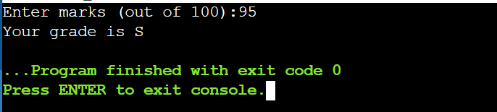

**SET 1 – Q3.**

#include <iostream>

using namespace std;

int main(){

int a,b,y;

char operation;

cout<<"Enter two numbers: ";

cin>>a>>b;

cout<<"Choose The Arithmetic Operation (+, -, /, x) : ";

cin>>operation;

switch(operation){

case '+': y = a + b; break;

case '-': y = a - b; break;

case '/': y = a / b; break;

case 'x': y = a * b; break;

default: cout<<"Invalid Operation";

}

cout<< y;

}

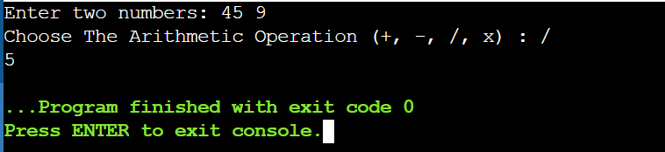

**SET 1 – Q4.**

#include <iostream>

using namespace std;

int main(){

int a[3][3],i,j;

cout << "Enter 9 elements for 3x3 array\n";

for(i=0;i<3;i++)

{

for(j=0;j<3;j++)

{

cin >> a[i][j];

cout << a[i][j] << " ";

}

cout << endl;

}

}

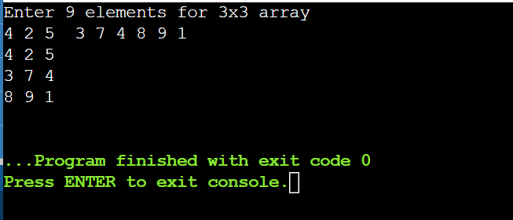

**SET 1 – Q5.**

#include <iostream>

using namespace std;

int main()

{

int i, j, n;

cout << "Enter number of rows: ";

cin >> n;

for(i = 1; i <= n; i++)

{

for(j = 1; j <= i; j++)

{

cout << "* ";

}

cout << endl;

}

return 0;

}

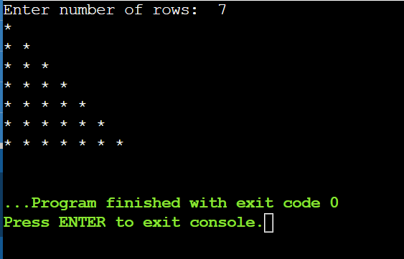

**SET 1 – Q11.**

#include <iostream>

#include <iomanip>

using namespace std;

int main()

{

int n=1,i=6;

cout << setw(30) << "AUGUST 2014" << endl << endl;

cout <<" "<< "SUN" << setw(7) << "MON" << setw(7) << "TUE" << setw(7) << "WED" << setw(7) << "THU" <<

setw(7) << "FRI" << setw(7) << "SAT" << setw(7) << endl;

cout << setw(42);

while (n<=31)

{

cout << n << setw(7);

if (i==7)

{

cout << endl;

i=0;

}

n++;

i++;

}

return 0;

}

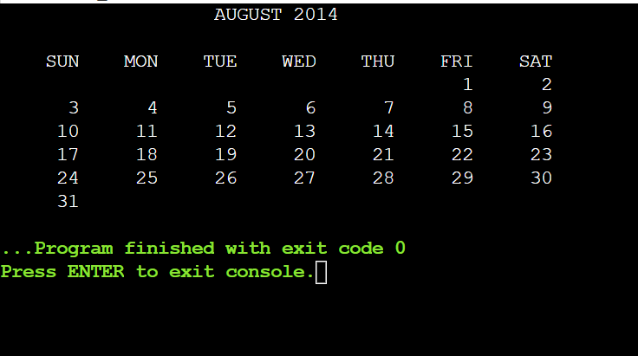

**SET 1 – Q12.**

#include <iostream>

using namespace std;

int main(){

int n, r, rev = 0,sum = 0;

cout << "Enter an integer: ";

cin >> n;

while (n != 0){

r = n % 10;

rev = rev * 10 + r;

n = n / 10;

}

cout << "Reversed Number: " << rev << endl;

n = rev;

while (n != 0) {

sum = sum + n % 10;

n = n / 10;

}

cout << "The sum of the digits : "<< sum;

return 0;

}

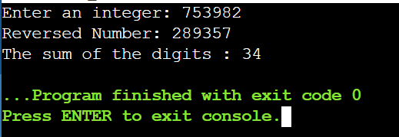

**SET 2 – Q1.**

#include <iostream>

#include <cmath>

using namespace std;

int factorial(int x){

int fact=1;

for(int j=1;j<=x;j++){

fact=fact*j;

}

return fact;

}

int main()

{

int i,n;

float sum=0,x;

cout<<"Enter the no. of elements and the value of x : ";

cin>>n>>x;

for(i=0;i<n;i++){

sum=sum+pow(x,2*i+1)/factorial(2*i);

}

cout<<"Sum of the expansion = "<< sum;

return 0;

}

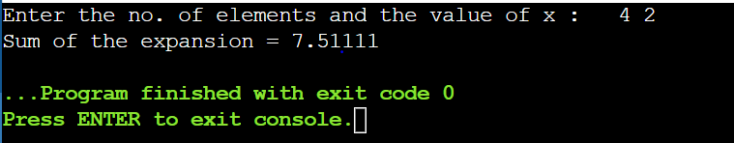

**SET 2 – Q2.**

#include <bits/stdc++.h>

using namespace std;

void print(int n)

{

int var1 = 1, var2 = 1;

for (int i = 0; i < n; i++) {

for (int j = n - 1; j > i; j--) {

cout << " ";

}

for (int k = 1; k <= var1; k++) {

cout << abs(k - var2);

}

var1 += 2;

var2++;

cout << "\n";

}

}

int main()

{

int n;

cout << "Enter number of lines:";

cin >> n;

print(n);

return 0;

}

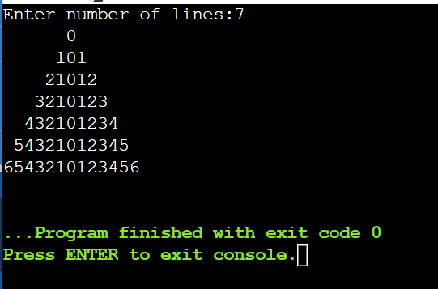

**SET 2 – Q3.**

#include <bits/stdc++.h>

using namespace std;

int main()

{

int n,x;

cout << "Enter number of lines & number for x:";

cin >> n >> x;

for(int i=1;i<=n;i++)

{

for(int k = 1; k <= n-i; k++)

cout <<" ";

for(int j=1; j<=i; j++)

cout << pow(x,i)+j << " ";

cout << endl;

}

return 0;

}

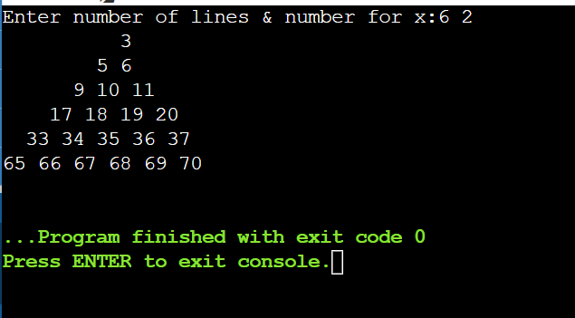

**SET 2 – Q4.**

#include <iostream>

using namespace std;

int decresingOrder(int n)

{

int j,r=0,l;

int count[10]={0};

while (n){

count[n%10]++;

n/=10;

}

for(j=9;j>=0;j--)

for(l=0;l<count[j];l++)

r=r*10+j;

cout << r << " ";

return r;

}

int main()

{

int num1,num2,num3;

cout << "Three Numbers: ";

cin >> num1 >> num2 >> num3;

cout << "The modified numbers are: ";

int x = decresingOrder(num1);

int y = decresingOrder(num2);

int z = decresingOrder(num3);

if((x >= y) && (x >= z))

cout << endl<< "Largest number: " << x;

else if ((y >= x) && (y >= z))

cout << endl << "Largest number: " << y;

else

cout << endl << "Largest number: " << z;

return 0;

}

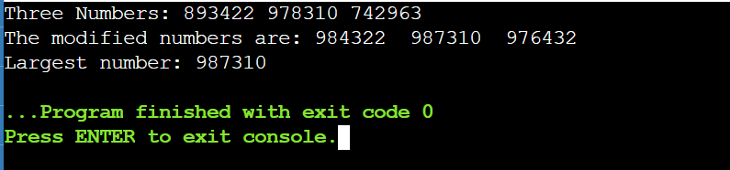

**SET 2 – Q5.**

#include<iostream>

using namespace std;

long factorial(int a);

int main()

{

int a=0,b=1,c,n;

cout<<"enter a number"<<endl;

cin>>n;

cout<<"Number(n)"<<" "<<"factorial(n!)"<<endl;

cout<<b<<" "<<factorial(b)<<endl;

for(int i=1;i<=n;i++)

{

c=a+b;

cout<<c<<" "<<factorial(c)<<endl;

a=b;

b=c;

}

return(0);

}

long factorial(int n){

long fact =1;

for(int i=1;i<=n;i++)

{

fact=fact*i;

}

return(fact);

}

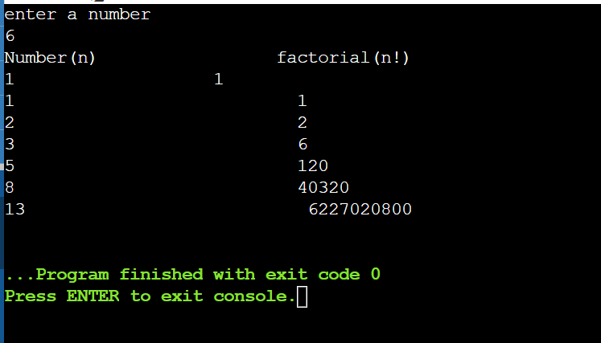

**SET 2 – Q6.**

#include <iostream>

using namespace std;

int main()

{

char line[150];

int vowels,nonalpha;

vowels = nonalpha = 0;

cout << "Enter a line of string: ";

cin.getline(line, 150);

for(int i = 0; line[i]!='\0'; ++i)

{

if(line[i]=='a' || line[i]=='e' || line[i]=='i' ||line[i]=='o' || line[i]=='u' || line[i]=='A' ||

line[i]=='E' || line[i]=='I' || line[i]=='O' ||line[i]=='U')

++vowels;

else if(!(line[i]>='a'&& line[i]<='z') && !(line[i]>='A'&& line[i]<='Z'))

++nonalpha;

}

cout << "No.of Vowels: " << vowels << endl;

cout << "No.of NonAlpha: " <<nonalpha<< endl;

for(int i = 0; line[i]!='\0'; ++i)

{

if(line[i]=='a' || line[i]=='e' || line[i]=='i' ||line[i]=='o' || line[i]=='u' || line[i]=='A' ||

line[i]=='E' || line[i]=='I' || line[i]=='O' ||line[i]=='U')

{

cout<<"first occurence of vowel:"<<i;break;

}

}

return 0;

}

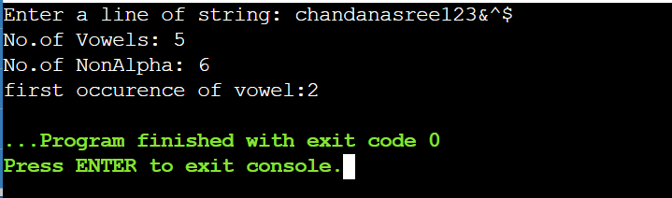

**SET 2 – Q7.**

#include <bits/stdc++.h>

using namespace std;

void removeDuplicates(char* str)

{

int i = 0;

if (str[0] == '\0')

return;

if (str[0] == str[1]) {

while (str[i] != '\0') {

str[i] = str[i + 1];

i++;

}

removeDuplicates(str);

}

removeDuplicates(str + 1);

}

int main()

{

char str1[30];

int i;

cout<<"Enter a string[30]:";

cin>>str1;

for (i = 0; str1[i]; i++);

cout << "Length of String before processing: " << i << endl;

removeDuplicates(str1);

cout << str1 << endl;

for (i = 0; str1[i]; i++);

cout << "Length of String after processing: "<< i << endl;

return 0;

}

